Congratulations to our outstanding Year 10 and Year 12 classes of 2022!
Yesterday and last week marked a return to the traditional results days after an anxious wait for results. We were delighted to welcome the pupils into school to receive their results and we have been delighted with the successes of the pupils enabling them to embark on the next stage of their academic journey and their lives. Many Year 11 pupils are returning to study with us here at Archbishop McGrath and we are thrilled to have them staying with us for the next two years. Those pupils who are following specialist courses at colleges have been receiving confirmation of their places and we are so pleased for them to begin the next step of their specific journey. In addition, we are delighted with the numbers of pupils who are embarking on apprenticeships or already have a job starting their careers. Similarly, with our Year 13 pupils last week achieving their results, they are now busy preparing for their start at university, apprenticeships or careers.
However, last week and yesterday represented days of nervously waiting for two other year groups who should not be forgotten. Last week, our Year 12 pupils received their AS results and yesterday, our Year 10 pupils received results for a number of GCSE specific papers. These results have demonstrated the potential of the pupils and we look forward to some outstanding GCSE and A level results next year.
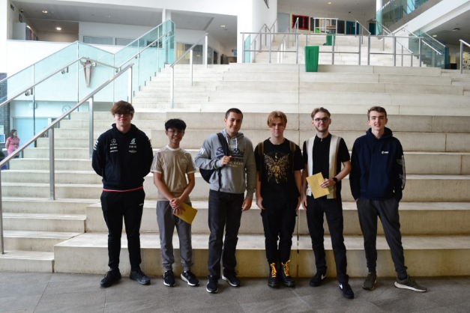
Year 12 achieved some of the best AS results we have ever had and this suggests that next year’s A level results will be very impressive. These pupils were unable to sit GCSE exams and these AS exams represented the first exams they had sat. They worked hard and prepared carefully to maximise their success. Their resilience and determination have been remarkable and they have adjusted to Key Stage Five studies and the demands of the new courses and managed their own studies to ensure they achieved the best grades possible. They have engaged fully in the life of the school and have ensured they have taken every opportunity offered with pupils engaging in summer schools and work experience placements to carefully consider their university choices and their courses ready for their careers.
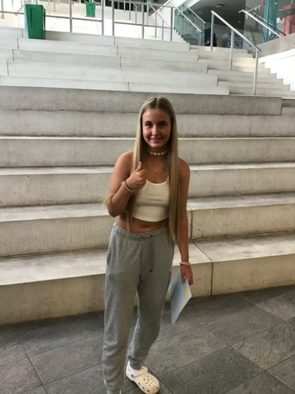
Year 10 have worked tirelessly to ensure they made the most of the opportunity to sit these modules early to relieve some of the pressure on themselves next year. Many pupils sat papers in six subjects and have completed NEAs this year, reducing the amount of work they will need to complete next year and already achieving impressive grades in the specific papers sat. They coped with taking their options at the end of the last lockdown and have demonstrated tremendous maturity and determination throughout the start of their Key Stage Four studies.
Whilst Year 10 and Year 12 are returning to complete their studies In September, their achievements should not be underestimated. They have successfully completed the first year of their studies, providing a solid foundation to progress next year. This year will ensure they have given themselves the best possible start to their exam courses and I know they will further develop, going from strength to strength next year.
I think Mr Green summed up everyone’s feelings when he said “It has been a pleasure to witness these pupils grow and develop into resilient and motivated young adults. I am sure Year 10 will continue to contribute to the school community in Year 11 and to the greater good in society (EVE) and Year 12 will continue to contribute to the school in the Sixth Form and to the greater good in society as they go out into the world following the paths for which God intended them. I am looking forward to working with these pupils more closely to further develop and refine our school community - #TogetherWeAreStronger. These pupils should aim to exceed their expectations and should think about their legacy, because they are writing it every day. They need to remember the secret to success is hard work and commitment.”
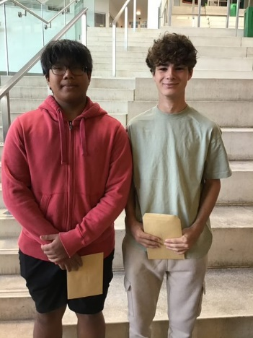
I hope the Year 10 and Year 12 pupils realise how much they have achieved and how far they have come. They should be so proud of themselves. I know there will be some pupils reading this who may have been slightly disappointed by their results this year but they have still achieved so much as they will now realise the importance of sitting formal exams as it helps them reflect and prepare for next year. Their teachers will be able to help them prepare for next year and they can work on areas where they could improve.
These classes of 2022 have been exceptional despite the challenges they have faced; I know they will go on to achieve highly and I look forward to their future success. They should not underestimate their achievements this year or their potential for next year. It has been the greatest honour to be their Acting Head of School this year and a real privilege. Like Year 13 and Year 11, these young people have demonstrated how they can, and will, shape their futures and the world around them. They have inspired those around them and I know they will continue to have a positive impact on the school community.
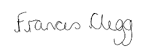
Frances Clegg

Acting Head of School

