Congratulations to the Year 11 class of 2022!
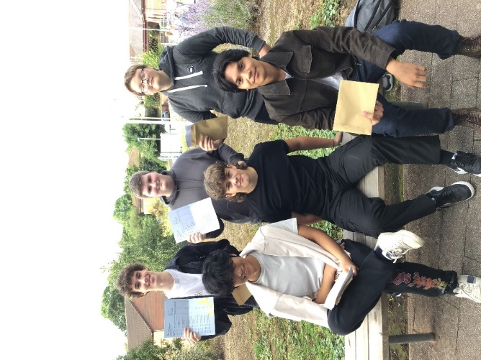
For the second time this month I will say…’What a year, but what a year group!’ Like Year Thirteen, for the class of 2022, today was a return to a more ‘normal’ and ‘traditional’ results day. However, this year has been anything but ‘normal’ and this incredible year group have not only experienced significant disruption throughout their Key Stage Four studies but also during their Key Stage Three studies. Undeterred, this resilient and committed group of students have provided a blueprint for younger years in how to flourish and excel in the most difficult of circumstances. They sat external exams for the first time this year and not only coped well but achieved incredible results. In a similar way to their peers in Year Thirteen, this group of pupils are incredible – they are resilient, good humoured, committed and dedicated and they have not allowed anything to get in their way of achieving the best grades possible, ensuring they can all access their chosen courses and career pathways in September.
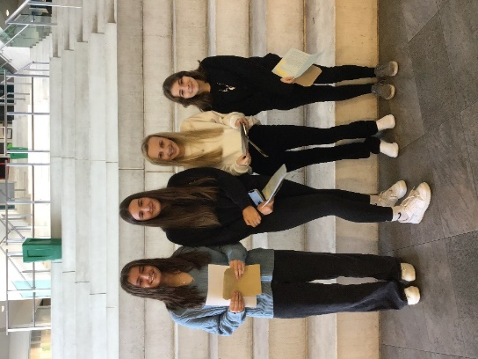
As a school, we are exceptionally proud of their academic achievements and the dedication with which they have approached their GCSE studies but also of the strength of character and resilience Year 11 have shown in these extraordinary circumstances. The class of 2022 have made an outstanding contribution to the wider life of the school and have been a source of inspiration to younger students. They have experienced so much disruption and yet they endeavoured to support the school throughout the lockdowns and since they have returned this year. They are a talented and ambitious cohort who we look forward to welcoming back into Sixth Form in September, and we also look forward to hearing of the success of those pupils who are following the next stage of their academic journey at other educational establishments or starting careers.
Mr Green commented, “It is truly inspirational to witness the pupils achieving their great GCSE results. The resilience they have demonstrated to overcome such a challenging year is something of which the pupils should be extremely proud. May this success lead to greater achievements in the years to come. Good luck, and I will look forward to working with the pupils once more when attending Sixth Form. For those pupils who will be choosing an alternative path, there is no secret to success. It is the result of preparation, hard work, and learning from our failures. Believe in yourself and all that you are. Know that the CPP virtues are inside you which will help you overcome any obstacle in your futures. Congratulations!”
Raising Standards Leader, Mrs Farrow, who has tracked the learners’ progress, summed it up: “All learners have shown great resilience over the past few months and have achieved outstanding results; I am extremely proud of all Year 11 pupils and their destinations and pathways for next year.”
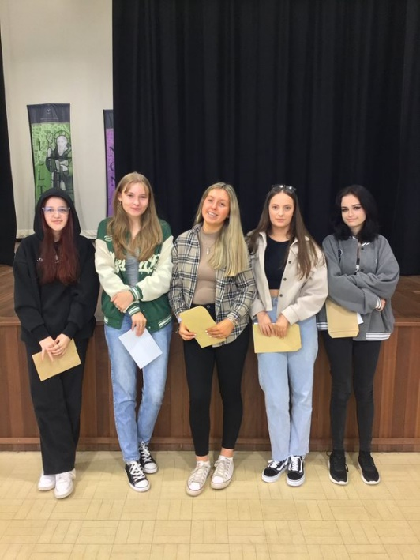
Mr Farrow said he is immensely proud of all of the students for coping with two years of disrupted education in such a mature and discerning way. “Achieving outstanding GCSE results following two years of disruption is evidence of your resilience and ability to adapt. These are life skills you will never forget. Every one of you should be proud of your individual performance. I wish you every success in your future."
Mr Davies believes “these GCSE results are not a reflection of missed exams but of the years of effort and cumulative attainment that these extraordinary pupils have undertaken since Year 7. They should be justifiably proud of their results.”
Mr Evans said, “Congratulations to each of you on your individual achievements. I wish you every success with your next steps, whether these be returning to Archbishop for 6th Form or leaving to attend college, undertake an apprenticeship or venture into the world of work. You take with you all the virtues and skills required to be the best version of yourselves.”
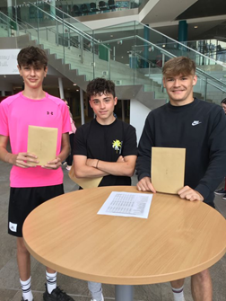
Mr Muggleton said, “Some amazing results have been achieved by many pupils from this year group. After sticking with studies through many difficulties and disruption, they have risen to the challenge and achieved results better than many hoped for. I wish everyone well in the future wherever these results take you. God bless and keep your faith real to guide you forward in your life choices.”
And the best is yet to come!
A significant number of our Year 11 pupils will be returning to study Level 3 qualifications with us here at Archbishop McGrath and with their exemplary GCSE grades they will no doubt go on to achieve amazing things over the next two years. Others are going to specialist colleges to study vocational qualifications and we wish them every success and much happiness in their chosen fields.
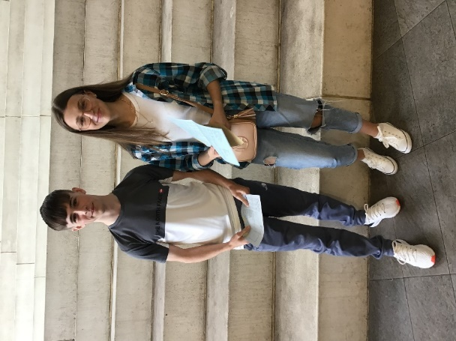
As documented in July in an earlier letter, any pupil wishing to join our Year Twelve (2022-2023) will need to enrol on Monday September 5th at midday at the school in the Sports Hall. This is regardless of having/not having submitted final option choices or even if they had indicated they would not be returning to Archbishop McGrath but have subsequently changed their mind. They will not need to wear school uniform on this day.
This enrolment is important for us to ensure we have the correct information from the students as their A level choices may have changed on receiving their GCSE results or have changed since they completed their option selection last term, and so that we can ensure that timetables are correct.

The Year 11 class of 2022 have been exemplary and a real credit to themselves and their families throughout their school career. Despite the disruption they have experienced during all of their Key Stage Four, they have shown resilience and commitment. The future is still uncertain but despite this, as they start the next stage of their academic and employment journey, I know that this wonderful group of students will go on to achieve great things. I feel privileged to have been their Acting Head of School and look forward to hearing news of their many future successes.
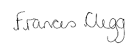
Frances Clegg

Acting Head of School

