Congratulations to our outstanding class of 2022
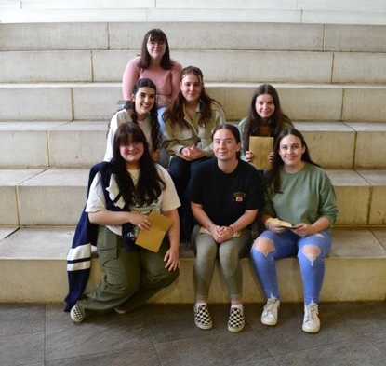
What a year, but what a year group! For the class of 2022, yesterday was a return to a more ‘normal’ and ‘traditional’ results day. However, this year has been anything but ‘normal’ and this incredible year group have not only experienced significant disruption throughout their Key Stage Five studies but also during their Key Stage Four studies. Undeterred, this resilient and committed group of students have provided a blueprint for younger years in how to flourish and excel in the most difficult of circumstances. They sat external exams for the first time this year without the ‘training’ of AS exams or GCSE and not only coped well but achieved incredible results.
We are absolutely delighted with their academic achievements but also of their tremendous strength of character and resilience shown throughout Key Stage Five. The class of 2022 have made an outstanding contribution to the wider life of the school and have been a source of inspiration to younger students. They have experienced so much disruption and yet they endeavoured to support the school and their communities throughout the lockdowns and, during this year, have supported whole school events as we have slowly returned to normal. They have been an aspirational and inspirational year group.
Mr Green summed up the views of us all at the school when he said he is immensely proud of all the students for coping with the transition back to traditional school life in such a mature, resilient, and discerning way. “I wish every one of the students the best of luck as they head off to the next step in their lives. There are no secrets to success. It is the result of preparation, hard work, and learning from our failures. Believe in yourself and all that you are. Know that the CPP virtues are inside you which will help you overcome any obstacle in your futures. Good luck!”
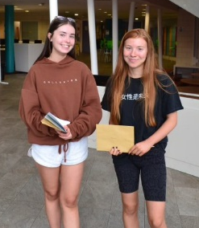
Miss Pearson, Head of Sixth Form, said “Our students have faced the challenges that the pandemic has brought to their academic journey from GCSE and A level with grace, integrity, determination, resilience, courage and always good humour. They have truly been an inspiration and I am so proud of each and every one of them. They have achieved outstanding results and it has been a privilege to be a part of their journey. I know they will continue to be magnificent and fearless in the face of adversity, and hopeful no matter what life may throw at them."

Mr Farrow, Acting Deputy Headteacher, said he is immensely proud of all of the students for coping in such a mature and discerning way. “Every pupil should be proud of their individual performance. I wish you every success in your future and am confident you will achieve your dreams.”
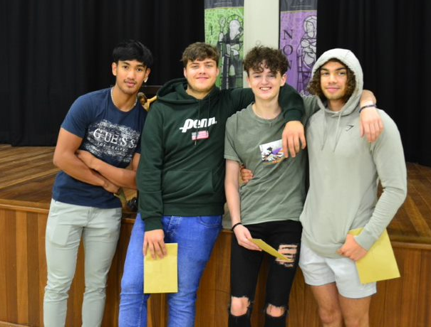
Mr Davies, Assistant Headteacher, said "These outstanding pupils will leave us Empowered, Virtuous and Employable. They may not be taught here anymore but will always be part of the Archbishop McGrath community."
Mr Evans, Assistant Headteacher, joins in congratulating the students on their tremendous results. “The pupils have shown outstanding resilience, hard work and determination to achieve excellent examination results; they should each be extremely proud of their individual achievements. I wish them all the very best for the future.”
Mr Muggleton commented that he is “…always amazed to see how results days turn out for all pupils, and the different places and opportunities that develop on the back of hard work and dedication. I am truly inspired by some of the choices of careers and further learning that many students are going on to, and am proud that they will be leaders of the future. Just remember that the Lord is with you and you can lean on Him; let Him guide you.”
Celebration!
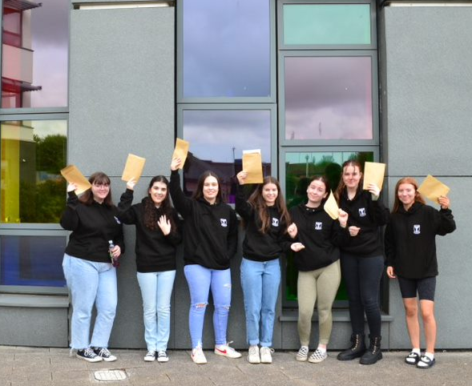
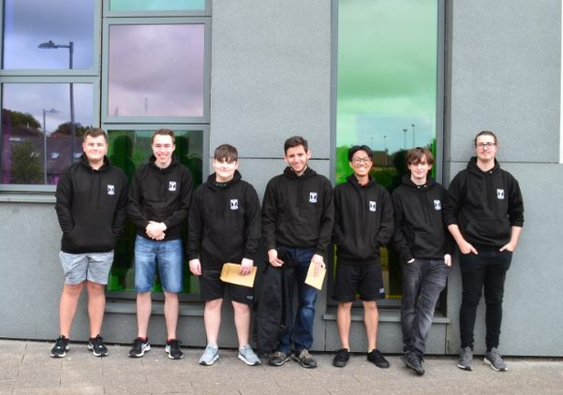
Our learners have achieved some exemplary grades and even an incredible number of A or A* grades during the most challenging of circumstances and it is reassuring to know so many learners have been offered places in their first choice of university or in jobs or apprenticeships.

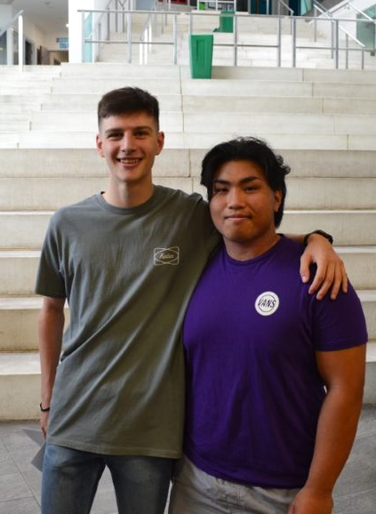
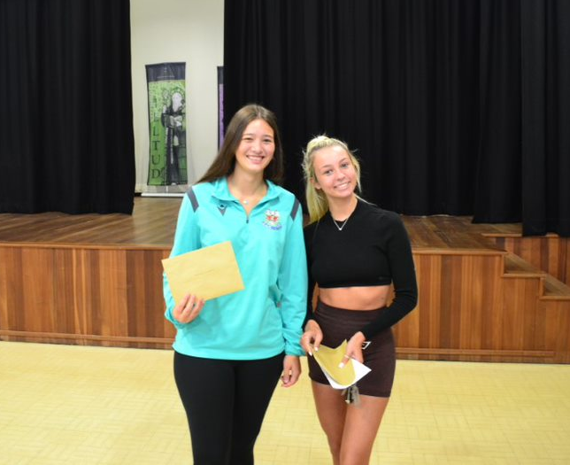
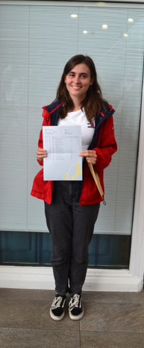
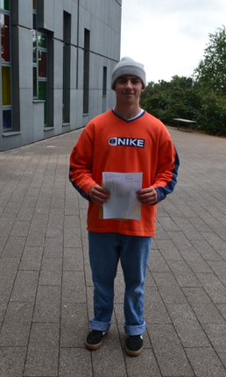
The class of 2022 have been an exceptional year group throughout their school career. Despite the challenges they have faced and the uncertainties ahead, I know that this exceptional group of students will go on to achieve highly and I look forward to hearing of their future success. They should not underestimate their achievements this year as the first Year Thirteen cohort to return to formal examinations. It has been the greatest honour to be their Acting Head of School this year and a real privilege. These young people have demonstrated how they can, and will, shape their futures and the world around them. They have inspired those around them and left a lasting legacy at the school. I wish them all a very happy, healthy and successful future and know they will have a positive impact on all those around them.
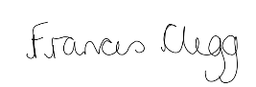
Frances Clegg

Acting Head of School

