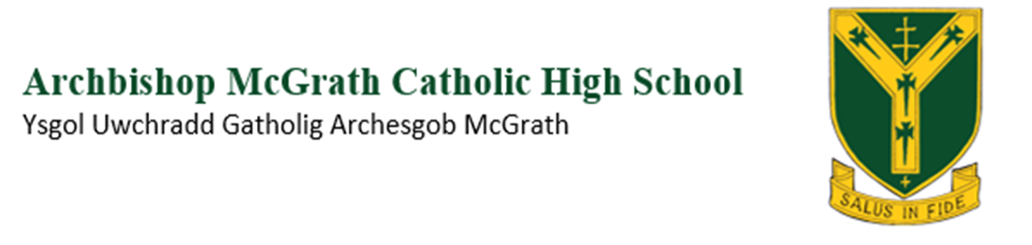
Year 12 and 13, Assessment Calendar 2025 – 2026
DATE | SUBJECT / YEAR
September
 | Chemistry Y12 (Unit 1 & 2) and Y13 (Unit 3 & 4) End of Topic Tests – After each topic throughout academic year
 | English Yr12 (Units 1 & 2) Timed mini exam-style tasks on Jane Eyre, A Streetcar Named Desire & poetry by Duffy & Larkin throughout the academic year.
Physics Y12 – Particles
Physics Y13 – Capacitance and Orbits and the Wider Universe
 | ASBW Y12 – 26/09/25 GCP Task 1a (NEA)
ASBW Y13 – 12/09/25 Individual Project Task 3 (NEA)
ASBW Y13 – 19/09/25 Individual Project Task 4 (NEA)
ASBW Y13 – 26/09/25 Individual Project Task 5 (NEA)
 | History Y13 NEA – Origins of the Cold War (ongoing)
 | Maths Year 12 Autumn Assessment
October | Physics Y12 – Using radiation to investigate stars
 | Business Y13 – 17/10/25 - Unit 4
 | Psychology Y13 – 21/10/25 - Unit 3
 | Psychology Y12 – 22/10/25 - Unit 1
 | Business Y12 – 22/10/25 Unit 1
 | ASBW Y12 – 17/10/25 GCP Task 1b (NEA)
ASBW Y13 – 10/10/25 Individual Project Task 7 (NEA)
ASBW Y13 – 17/10/25 Individual Project Task 8 (NEA)
ASBW Y13 – 24/10/25 Individual Project Task 9 (NEA)
November | Physics Y12 – Solids under stress  Physics Y13 – Magnetic fields
 | Maths Year 13 Autumn Assessment
 | ASBW Y12 – 21/11/25 GCP Task 2 (NEA)
ASBW Y13 – 07/11/25 Individual Project Task 10 (NEA)
ASBW Y13 – 14/11/25 Individual Project 1st Draft (NEA)
ASBW Y13 – 21/11/25 Individual Project 2nd Draft (NEA)
ASBW Y13 – 28/11/25 Individual Project Final Draft (NEA)
December
Maths Unit 1 Pure PPE Year 12
Maths Unit 2 Applied PPE Year 12
Maths Unit 3 Pure PPE Year 13
Maths Unit 4 Applied PPE Year 13

Chemistry Y12 Unit 1 and Y13 Unit 3 Mock Exam (TBC)
Physics Y12 Unit 1 and Y13 Unit 4 Mock Exam (TBC)
 | Business Y12 Mock Unit 1 (TBC)
 | Business Y13 Mock Unit 3 (TBC)
 | Psychology Y13 Mock Unit 3&4 (TBC)
 | Psychology Y12 Mock Unit 1 & 2 (TBC)
 | History Y12 Mock Unit 1 & 2 (TBC)
 | History Y13 Mock Unit 3 & 4 (TBC)
 | English Yr 12 Mock Units 1 & 2 (TBC)
 | English Yr 13 Mock (Shakespeare & Chaucer) TBC
January | English Yr 13 NEA draft  (Shorter draft sections will have been submitted before January)
February | ASBW Y12 – 27/02/26 GCP Task 3 (NEA)
 | English Yr 13 – Final NEA – specific date TBC
March
April
 | Chemistry Y12 Unit 2 and Y13 Unit 4 Mock Exam (TBC)
 | Business Y12 Mock Unit 1&2 (TBC)
 | Business Y13 Mock Unit 3&4 (TBC)
 | Psychology Y13 Mock Unit 3&4 (TBC)
 | Psychology Y12 Mock Unit 1&2 (TBC)
May
June
July

