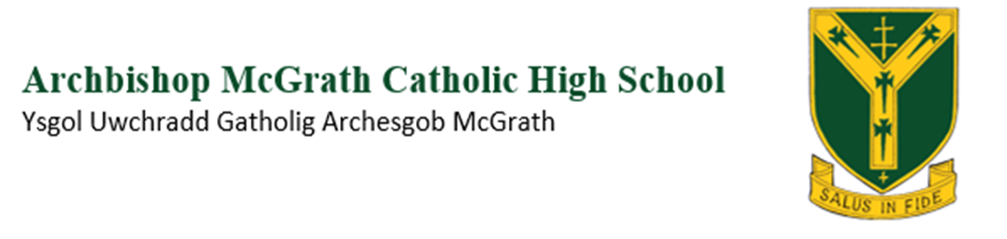
Year 11 Calendar 2024 – 2025
DATE | SUBJECT
September - October | History  NEA in class
1st and 3rd October | Geography  Fieldwork
September – January. | DigiTech  NEA assessment in class
9th October | Media  NEA first draft coursework.
8^{th,} 10th and 11th October | Food and Nutrition (See member of staff for exact date)  Unit 1 NEA
18th October | Drama  NEA
October / December | Geography  NEA assessment in class
4th and 6th November | Numeracy  Drop down
5th and 7th November | Numeracy  EXTERAL EXAM
22nd November | PE (2 hour) in class  NEA Controlled assessment
WB – 24th November | English Literature (See member of staff for exact date)  NEA in class
26th and 27th November | Applied Science (See member of staff for exact date)  External Practical assessment
28th November | Media  NEA Final coursework completed.
13th December | Art  Hand in Unit 1 ( worth 60% of the qualification)
2nd December -13th December | Pre Public Exams (Mocks)
6th January | Opening of the Art Examination paper for the GCSE Externally Set Assignment.
13 -17th January | English Oracy  NEA – Group work
22nd - 23rd | Welsh Oracy  PPEs
24th January | PE ( 2 hours ) in class  NEA – Controlled assessment
28th, 29th, 30th January | Science ( staff member will speak with you )  Practical’s NEAs
31st January | Physical education  Practical moderation
11th and 12th February | Music  Music Practical Examination
Wb 3th March | Food and Nutrition  Practical controlled assessment - NE2
TBC February | PE  External moderator
11th March | Music  Final composition submission
25th , 26th and 27th March | Welsh  Unit 2 Speaking Exam
7th and 8th April - 11 A | Art  EXTERNAL EXAM
9th and 10th April 11B | Art  EXTERNAL EXAM
11th April | Art  Unit 2 submission
2nd May | Art  Unit 1 submission
Tbc May | French  Unit 1 Speaking Exam
TBC May | Drama  External exam
TBC May | GCSE EXAMAMINATION ( Individual timetables given to pupils)

*Classes will be informed when their appropriate NEA is.

